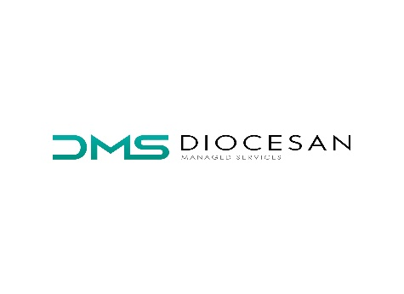

Cookie Policy
We respect the privacy of all visitors to our website. This Cookie Policy outlines our policy concerning the use of cookies on Diocesanms.ie.
This Cookie Policy contains important information about privacy and cookies and should be read together with our Privacy Policy.
We may update this Cookie Policy from time to time to reflect (i) any changes in technology or legislation (ii) the products or services we provide and/or (iii) how we operate our business which may affect the way in which cookies are used by us and how you as a user, can manage them.
What Are Cookies:
Cookies are small text files sent from a website and stored in the user’s web browser while user is browsing a website. They hold basic information such as have you visited our site before.
Which Cookies do Diocesanms.ie use:
When using our website there are two main categories of cookies that we use:
Session Cookies: These temporary cookies are not stored on your computer or mobile device. They are erased once your browser is closed or your session is inactive for 20 mins or more.
Persistent Cookies: Persistent or Duration cookies are placed on your computer or mobile device for a pre-determined duration once you visit a website.
We use Google Analytics to measure website performance. This is a web analytics service provided by Google Inc. Google Analytics sets a cookie in order to evaluate the use of those services and compile a report for us. These cookies do not contain any personally identifying information.
Managing / Removing your Cookies:
Most web browsers give you some control over whether you allow cookies to be collected. You can easily delete or clear cookies on your browser at any time.
If you do not wish to receive cookies, most browsers allow you to change your cookie settings. These settings will typically be found in the "options" or "preferences" menu of your browser.
To find out more about cookies, including how to see what cookies have been set and how to manage and delete them, visit www.allaboutcookies.org

